Understanding the German International Abitur
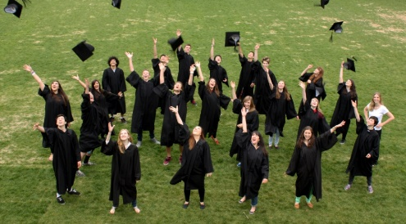
Information Chart
Understanding similarities between the German International Abitur (DIA) and the Quebec Highschool Diploma (DES) helps making decisions about your child’s academic future.

 | Quebec Highschool Diploma  (DES) | German International Abitur  (DIA)
Preparation | Student preparation for the DES starts in grade 9 with HQC* and geography, and continues in grade 10 with HQC, Science and Maths. In grade 11, students prepare in French and English.  *HQC: History of Quebec and Canada | Preparation for the Abitur starts in grade 10 with certain exams required to qualify for promotion to grade 11. The DIA program comprises grades 11 and 12, and marks obtained across the four semesters divided in two years count into the overall average.
Exams | Students take the Quebec provincial exams in grade 10 (HQC, Science and Maths) and grade 11 (English, French second language or mother tongue). | Students take 3 written exams beginning of February. German is mandatory.  Students take 2 orals exams at the end of grade 12.
CÉGEP  pre-university college | After obtaining their DES at the end of grade 11, students may attend Cégep.  They choose a 2-year program, allowing them to apply to a university, or a 3-year professional program to enter the job market or to study in their specific field.
University | After obtaining their Cégep diploma, students can study in Quebec or elsewhere in Canada.  To obtain an undergraduate academic degree (B.A.), a 3-year year program of studies is generally required.  A Cégep diploma may be recognized internationally but the process is not as straightforward as with the German International Abitur. | After successfully graduating from grade 12, students may attend university and obtain their B.A.  - in Quebec, where 3 or 4 years (including a year 0) are required depending on the faculty.  - elsewhere in Canada, where 3 to 4 years are required, depending on the study program.  - in Germany and worldwide generally in a 3-year study program.
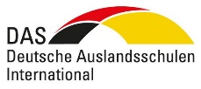
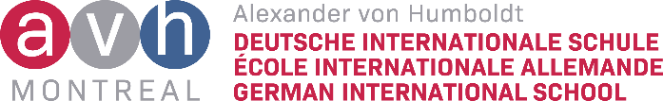
Call now or visit our website!
+1-514-457-2886
avh@avh.montreal.qc.ca
avhmontreal.ca

The German international Abitur is based on an international recognized university preparatory program. It is a diploma that provides and exceptional academic, cultural, and multilingual education to students of all nationalities and multicultural background.

